**summary(model1)**

Call:

lm(formula = V4 ~ ., data = xdata)

Residuals:

Min 1Q Median 3Q Max

-5.0475 -0.9138 0.0688 0.9695 7.2001

Coefficients:

Estimate Std. Error t value Pr(>|t|)

(Intercept) 32.6359 0.7502 43.50 <2e-16 ***

V1 54.5686 0.7029 77.63 <2e-16 ***

V2 -128.0465 0.7540 -169.83 <2e-16 ***

V3 9.6541 0.7820 12.35 <2e-16 ***

---

Signif. codes: 0 ‘***’ 0.001 ‘**’ 0.01 ‘*’ 0.05 ‘.’ 0.1 ‘ ’ 1

Residual standard error: 2.096 on 96 degrees of freedom

Multiple R-squared: 0.9975, Adjusted R-squared: 0.9974

F-statistic: 1.272e+04 on 3 and 96 DF, p-value: < 2.2e-16

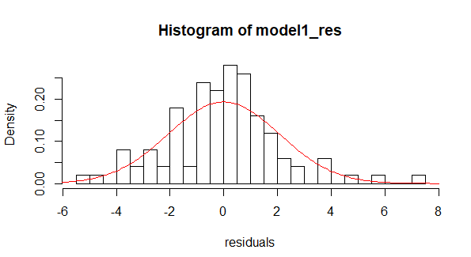

We can infer from above summary that V1 and V2 are positively correlated with V4 and V3 has a negative relationship with V4. And all variables V1,V2 and V3 are highly significant. Residuals vary from -5.0475 and 7.2001. And all the variables seem to similar standard error at 0.7* And looking at the histogram it deviates from normal distribution.

**> summary(model2)**

Call:

lm(formula = data.matrix(V4) ~ ., data = (xdata), weights = data.matrix(wdata))

Weighted Residuals:

Min 1Q Median 3Q Max

-0.56537 -0.10010 0.00131 0.08769 0.63438

Coefficients:

Estimate Std. Error t value Pr(>|t|)

(Intercept) 32.7400 0.7443 43.99 <2e-16 ***

V1 54.1966 0.6738 80.44 <2e-16 ***

V2 -127.8480 0.7221 -177.04 <2e-16 ***

V3 9.6161 0.7381 13.03 <2e-16 ***

---

Signif. codes: 0 ‘***’ 0.001 ‘**’ 0.01 ‘*’ 0.05 ‘.’ 0.1 ‘ ’ 1

Residual standard error: 0.1989 on 94 degrees of freedom

Multiple R-squared: 0.9977, Adjusted R-squared: 0.9977

F-statistic: 1.375e+04 on 3 and 94 DF, p-value: < 2.2e-16

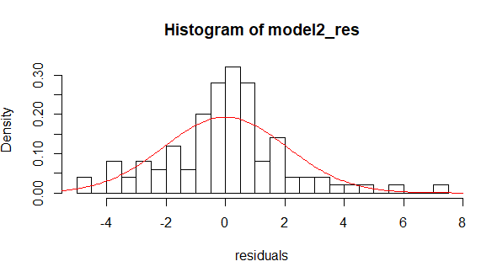

We can infer from above summary that V1 and V2 are positively correlated with V4 and V3 has a negative relationship with V4. And all variables V1,V2 and V3 are highly significant. Comparing it with model1 the residuals don’t vary too much and max,min have decreased to -0.5637 and 0.6438. The distance between max and min has decreased significantly indicating the value of residuals decreased significantly. Moreover, standard error has reduced a bit. Comparing histogram of both models model2 histogram seems more normally distributed.